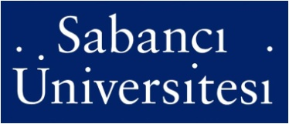
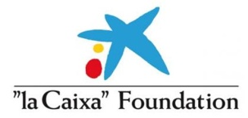
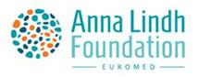

Euro-Mediterranean Studies Summer School
Anna Lindh/La Caixa Chair
Sabancı University
Istanbul, 8-12 September 2014

The Anna Lindh/La Caixa Chair, Faculty of Arts and Social Sciences, Sabancı University, announces the second summer school to be held on September 8 - 12, 2014.The purpose of this summer school is to
- Advance knowledge of the Euro-Mediterranean region and appreciation of its cultural diversity;
- Promote familiarity and intellectual exchange among youth from all countries of the region; and
- Engage students in intercultural dialogue.

Faculty:

Meltem Müftüler-Baç: Sabancı University, Anna Lindh/ Caixa Chair
Ahmet Evin: Sabancı University, Anna Lindh/ Caixa Chair
Yaprak Gürsoy: Istanbul Bilgi University
Emre Hatipoğlu: Sabancı University
Robert Manchin: Gallup Europe
Işık Özel: Sabancı University
Eduard Soler Lecha: Fundacion CIDOB, IBEI

To Apply:

Interested persons must send a letter of interest, a curriculum vitae and a transcript. Scholarships are available for new graduates and students enrolled in relevant masters programmes. The scholarships will cover food & accommodation and tuition fees. A certificate will be awarded to students who successfully complete the courses.
Applications should be sent to Oya Özer: oyaozer@sabanciuniv.edu / euromed@sabanciuniv.edu

PROGRAMME

Venue: Sabancı University Faculty of Arts and Social Sciences, Rm. FASS 2023
September 7 : Arrival of the participants
September 8
- 9:00 - 9:15 Welcoming remarks, Ahmet Evin on behalf of Sabanci University and Eduard
Soler on behalf of IBEI
- 9:30 - 11:30 From Partners to Neighbours in the Mediterranean Region, Eduard
Soler
- 12:00 - 13:30 Lunch Break
- 13:30 -16:30 The EU and the New Political Cycle in the Middle East and North Africa,
Eduard Soler
- 16:30 - 17:00 Discussion
September 9
- 9:30 -12:00 Turkish Foreign Policy in the Middle East and Europe, Meltem Müftüler-Baç
- 12:00 - 13:30 Lunch Break
- 13:30 - 16:30 Political Economy in the Mediterranean Region, Işık Özel
- 16:30 -17:30 Discussion
September 10
- 10:00 -16:30 Workshop on Intercultural trends and social change in the Euro-
Mediterranean region based on the Anna Lindh/Gallup Poll in the Anna Lindh
Report 2014, Robert Manchin
September 11
- 9:30 - 12:00 Online Social Media, Social Movements and Civil Society in Turkey /
Mediterranean, Emre Hatipoglu
- 12:00 - 13:30 Lunch Break
- 13:30 -16:30 The Economic Crisis in Southern Europe and Its Political Consequences,
Yaprak Gürsoy
- 16:30 - 17:30 Discussion

September 12
- 9:30 - 12:00 Energy Security and the Euro-Mediterranean Region, Ahmet Evin
- 12:00 - 12:30 Certificate presentations
- 12:30 Transfer to Karaköy and the hotel in centre city

September 13: Cultural sightseeing
September 14: Departure of the participants

