How to complete the online application form

- Please log in with your SU ID number and password to our online system via http://exchange.sabanciuniv.edu/node/add/staff-mobility

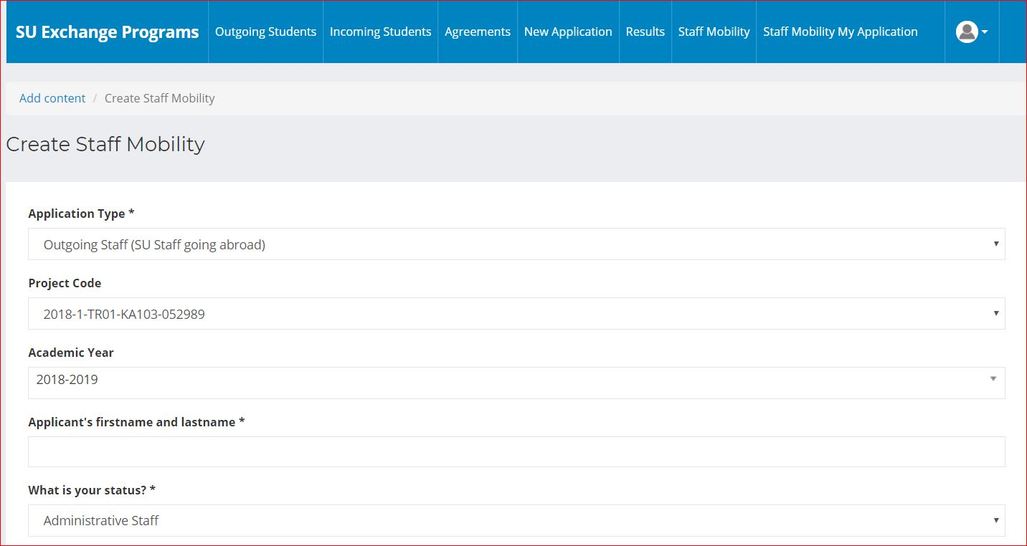

- Please select “Outgoing Staff (SU staff going abroad)” as your application type
- Please select “2018-TR01-KA103-052989” as a project code
- Please select “Administrative Staff” as your status

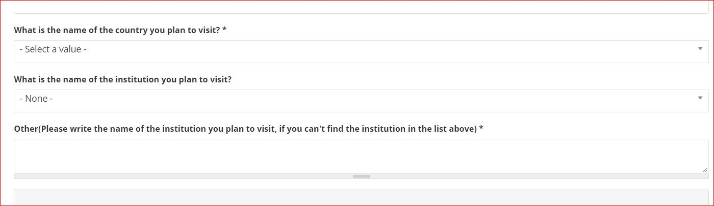

- Please select “the name of the institution you plan to visit” from the drop-down list*
*Please fill “Other” part with the name of the institution you plan to visit , if you cannot find the institution in the drop-down list.
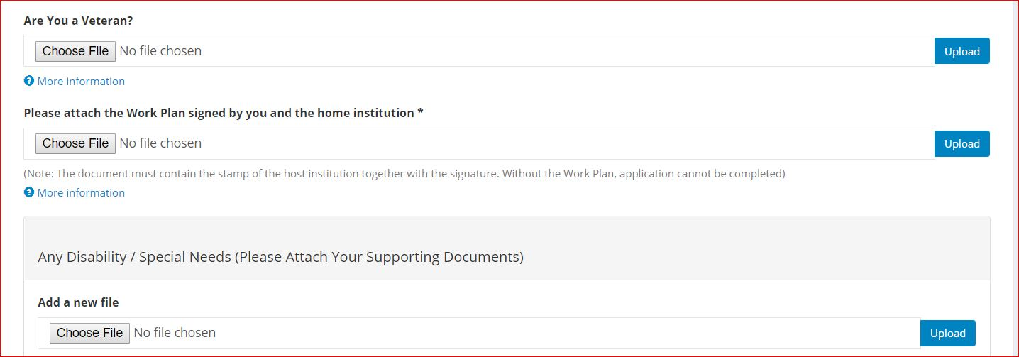
- Upload the work plan filled out by you, and signed by you and the host institution.
- Upload the English Language Certificate (Language test score showing your proficiency or a degree in undergraduate or graduate program entirely taught in English) OR a support letter approved by your unit executive/manager showing your Adequate Proficiency in the English Language.
- Please submit your application with “save” button.

