How to complete the online application form

- Please log in with your SU ID number and password to our online system via http://exchange.sabanciuniv.edu/node/add/staff-mobility

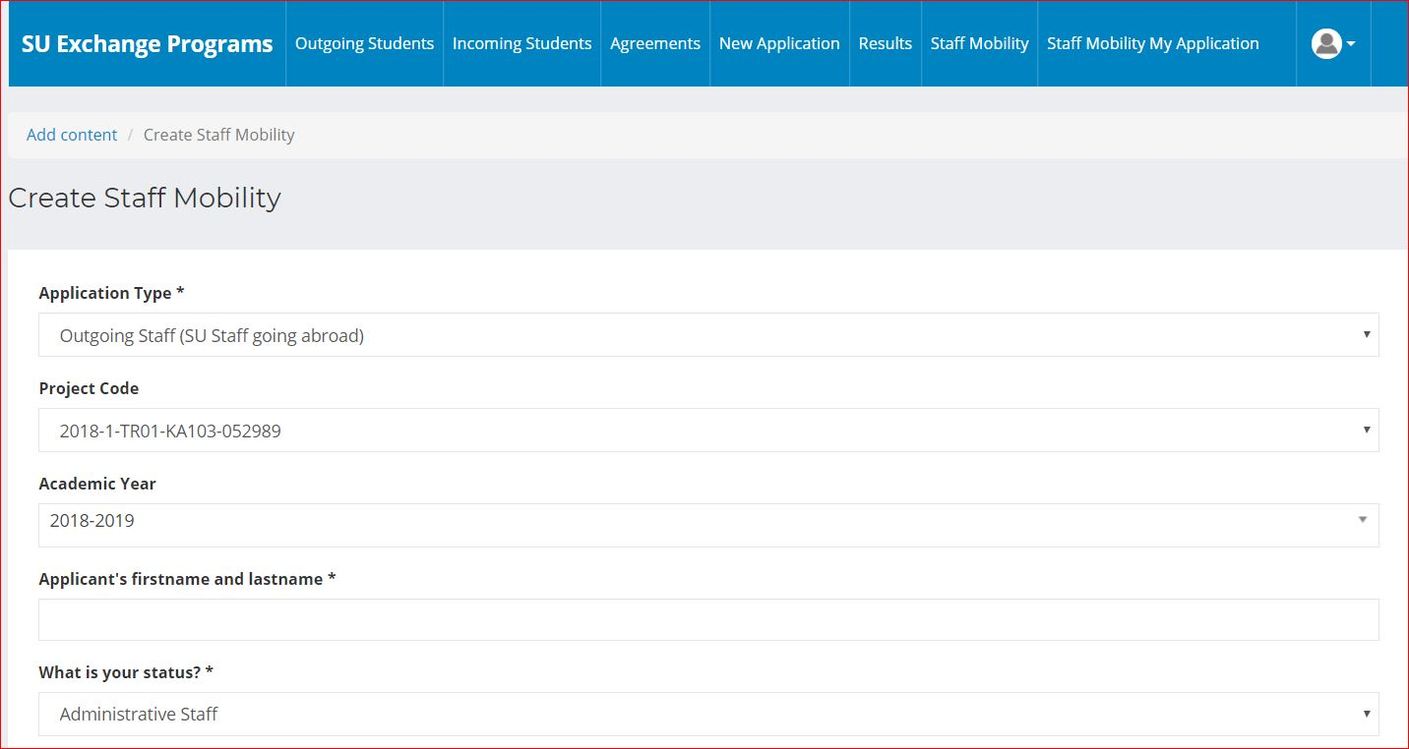

- Please select “Outgoing Staff (SU staff going abroad)” as your application type
- Please select “2019-1-TR01-KA103-066822” as a project code
- Please select “Administrative Staff” as your status

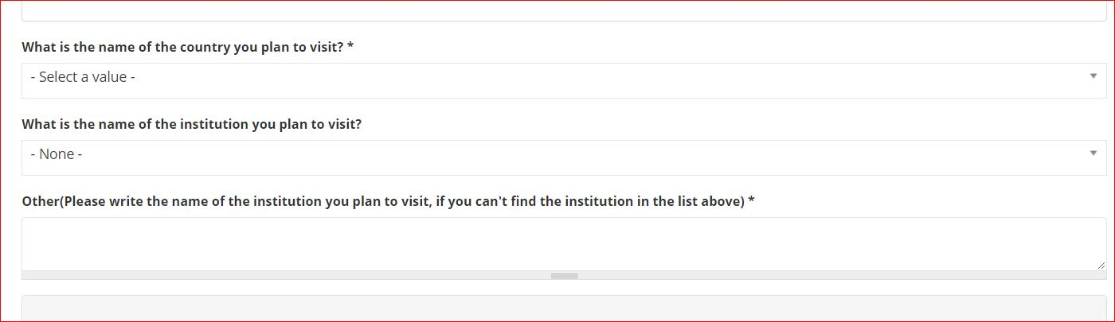
- Please select “the name of the institution you plan to visit” from the drop-down list*
*Please fill “Other” part with the name of the institution you plan to visit, if you cannot find the institution in the drop-down list.
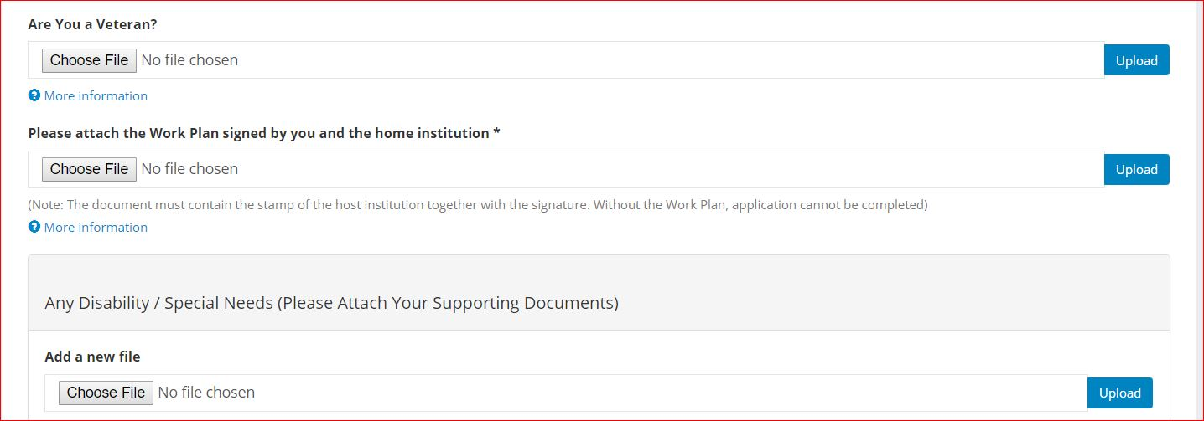
- Upload the work plan (staff mobility agreement) filled out by you, and signed by you and the host institution.
- Upload the language certificate/support letter.
- Please submit your application with “save” button.

If you have any inquiries, please do not hesitate to contact us (erasmus@sabanciuniv.edu or Phone: 9627)

